|  |
| --- |
| IOL Resource Accreditation RENEWAL |

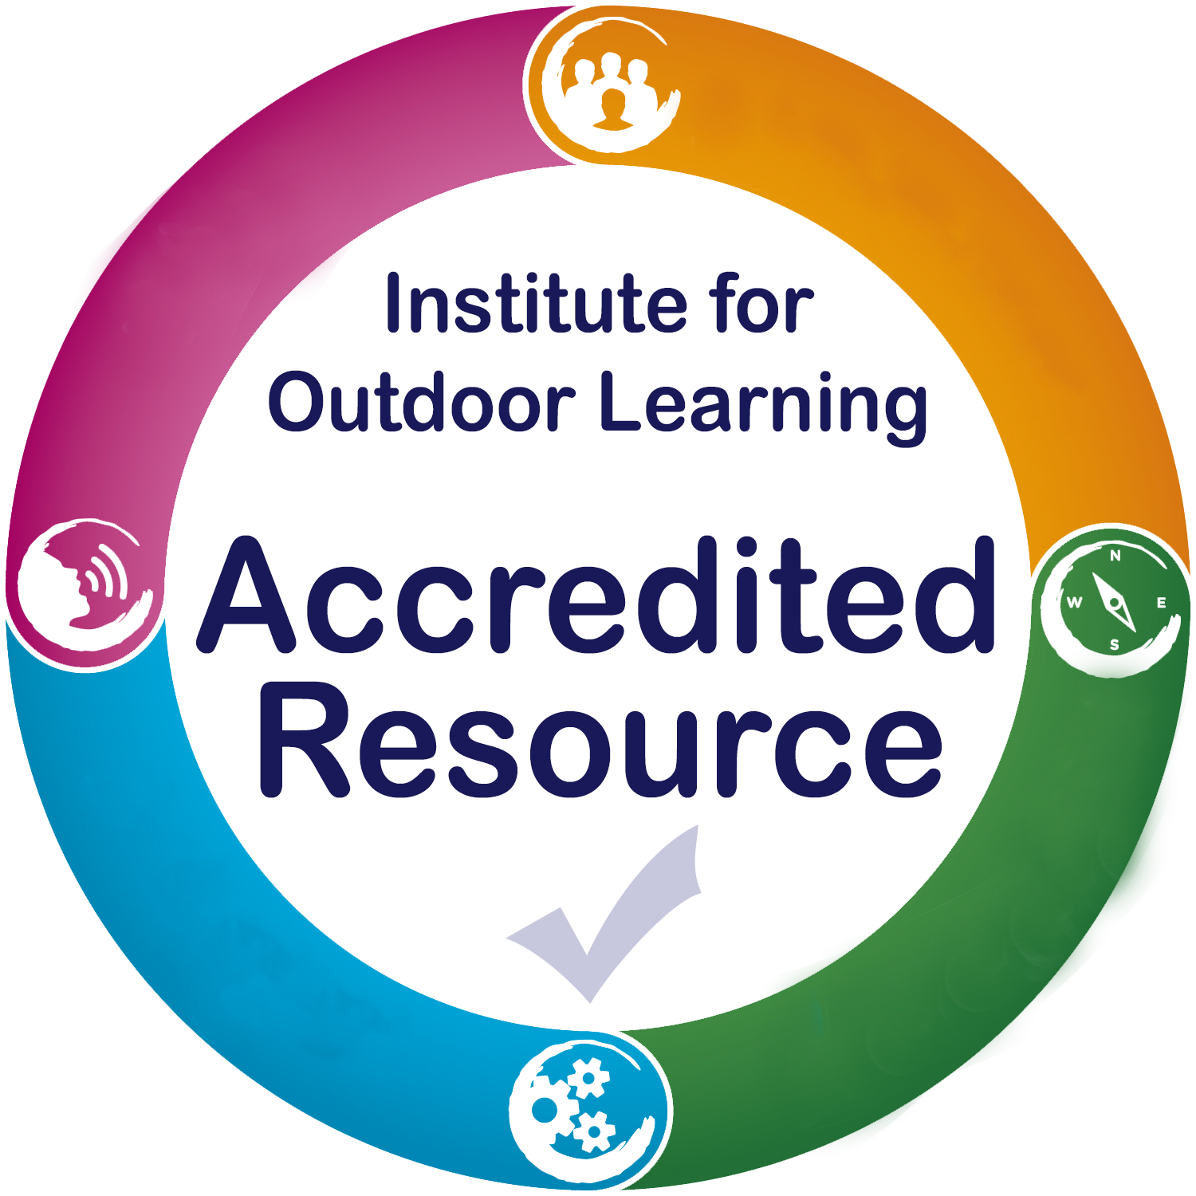A quality mark for resources that can support effective outdoor learning.

**For existing providers of an IOL Accredited Resource who wish to renew for a further period and update any details.**

|  |  |
| --- | --- |
| Resource Title |  |

|  |  |
| --- | --- |
| Provider Name |  |
| Contact Name |  |
| Contact Address |  |
| Phone |  |
| Email |  |

**Please re-read your accredited resource application before you complete this form.**

|  |  |  |  |
| --- | --- | --- | --- |
| **Have There Been Any Changes To The :** | | YES | NO |
| 1.1 | Ownership and rights to the intellectual property for this resource? |  |  |
| 1.2 | Resource design, content or structure? |  |  |
| 3.1 | Processes or systems users follow to obtain the resource? |  |  |
| 3.2 | Processes or guidance offered for using the resource? |  |  |
| 3.3 | Processes or approaches taken to monitor use and efficacy of the resource? |  |  |
| 4.2 | Organisations policies, procedures or insurance? |  |  |
| 5.2 | Resource Manager who oversees this resource? |  |  |

Please describe any changes below:

**Record Of Resource Provision**

|  |  |  |
| --- | --- | --- |
| Date range | Number of resources provided | Estimate of the number of people benefiting from the resource |
|  |  |  |
|  |  |  |

**Reflections on Resource Provision**

**Please summarise the feedback have you received**

**What improvements (if any) have you made this year?**

**What developments (if any) are you considering for the future?**

|  |
| --- |
| IOL Accredited Resource Application |

By applying to have you resource accredited by IOL you agree:

1. You hold the rights to the intellectual property for this resource
2. To send a sample of the resource to IOL for accreditation purposes
3. Your renewal will be assessed by the IOL Resource Accreditation board
4. To pay the appropriate fees for accreditation and renewal
5. You will provide IOL with the necessary information to create website links and promotional text for your accredited resource
6. The use of an IOL Accredited Resource Badge on any publications, products, websites or literature shall first be agreed with IOL.
7. IOL retains the right to withdraw accreditation at any time, including the reasons:

* Failure to comply with the accreditation criteria
* Failure to comply with the policies and processes submitted at accreditation
* Misuse of any branding, wording or logos of the Institute for Outdoor Learning

1. You will make opportunities and information available when requested for IOL to moderate the resource accreditation process

# Accredited Resource Application

Signed ______________________________ Position __________________________________

Name ______________________________ Date __________________________________

# Submitting your renewal

Our preferred method is via email with all files in .pdf format. Please send your completed form and attachments to [louise@outdoor-learning.org](mailto:louise@outdoor-learning.org)

It this is not possible, you can post you application to: Institute for Outdoor Learning, Warwick Mill Business Centre, Warwick Bridge, Carlisle, Cumbria. CA4 8RR

Louise will invoice you by return and we will begin assessing your application on receipt of payment.