Institute for Outdoor Learning

RPIOL Version 3.1, September 2020

RPIOL AWARD APPLICATION

|  |
| --- |
| Name |
|  |
| IOL membership number |
|  |
| IOL region |
|  |
| Preferred contact email |
|  |
| Preferred contact phone |
|  |
| Your RPIOL approved centre |
|  |
| Your RPIOL coach |
|  |

The RPIOL Award

Registered practitioners of the Institute for Outdoor Learning plan, prepare and lead safe and engaging outdoor learning sessions to achieve intended outcomes.

This application and your RPIOL coaching, employer backing, and professional discussion are designed to value your approach, understanding and experience in outdoor learning to:

## Reflective Process

**The application is designed as a reflective process to complete as you have conversations with your coach**. Aim to include:

* Examples from your practice.
* Your own thoughts, feelings, opinions, and methods.
* Evidence of your reflections, and how they have influenced your practice.
* Concise and purposeful writing that answers the questions asked – plan to keep within the space given.

**Take it one step at a time**. You can use pictures or illustrations if you wish. *(Use of video is not currently possible - we hope to be able to include it in the future).* Applications are assessed on the evidence that you present - work with your coach to make sure the important aspects stand out.

**Complete your RPIOL application in the best way for you**. Some candidates like to reflect first and then discuss their thoughts with their coach. Others like to talk with their coach first then record the key points of their discussion in their application.

## Assistance to complete your application

Please use any support necessary to type your spoken word, transcribe a recording, correct spelling or grammar, etc. Take a professional approach and make the necessary arrangements to suit your specific needs (see criterion 3.3). The IOL Professional Development Team can assist you if required.

section1

Reflecting on your experience

This section is a chance to look back on the full range of your outdoor learning education, training, experience, achievements, qualifications and key influences.

* Paid, part-role or voluntary experience delivering outdoor learning sessions

|  |  |  |
| --- | --- | --- |
| Dates | Organisation | Position |
|  |  |  |
|  |  |  |
|  |  |  |
|  |  |  |
|  |  |  |
|  |  |  |

* Duty of Care

|  |  |  |
| --- | --- | --- |
| Topic | Date last completed | Organisation / award gained |
| FIRST AID |  |  |
| SAFEGUARDING |  |  |
| MANAGING DATA |  |  |
| DISCLOSURE (DBS) |  |  |
|  |  |  |
|  |  |  |

* Education, training, and CPD courses

|  |  |  |
| --- | --- | --- |
| Date | Title | Qualification or award gained |
|  |  |  |
|  |  |  |
|  |  |  |
|  |  |  |
|  |  |  |

* Significant journeys / adventures / achievements

|  |  |  |
| --- | --- | --- |
| Where, what, with whom? | When, how long for? | High points / achievements |
|  |  |  |
|  |  |  |
|  |  |  |
|  |  |  |
|  |  |  |
|  |  |  |

* Membership of associations and clubs

|  |  |  |
| --- | --- | --- |
| Association, club or body | Membership dates | Specific role/contribution |
|  |  |  |
|  |  |  |
|  |  |  |
|  |  |  |
|  |  |  |
|  |  |  |

* Influences on your approach to outdoor learning

With your coach, discuss some of the reasons the outdoors is important to you. Reflect on key experiences and significant people, workshops, conferences, events, videos, books, etc. that have had an impact on you.

|  |
| --- |
| Date discussed: |
| Summary of the reasons the outdoors is important to you: |
|  |

section2

Professional practice

This section identifies the range of your consolidated experience and celebrates where you have come from and where you’re going next.

* Types of outdoor learning you are experienced delivering

|  |  |
| --- | --- |
| Areas of outdoor learning | Amount of experience |
| OUTDOOR EDUCATION (EARLY YEARS / SCHOOLS / FE) |  |
| OUTDOOR ACTIVITIES (INDIVIDUALS / FAMILIES / GROUPS) |  |
| YOUTH DEVELOPMENT / SCOUTS / DofE / etc. |  |
| HEALTH AND WELLBEING / ACTIVE LIFESTYLES |  |
| OUTDOOR / ADVENTURE THERAPY |  |
| EXPEDITIONS / ADVENTURE TOURISM |  |
| PROFESSIONAL DEVELOPMENT / CORPORATE TRAINING |  |

* Range of locations where you have consolidated experienced delivering outdoor learning sessions

|  |  |  |  |
| --- | --- | --- | --- |
| **BEACHES/SAND DUNES** |  | **CENTRE GROUNDS** |  |
| **CLIFFS** |  | **PARKS/GARDENS** |  |
| **ESTUARIES/MUDFLATS** |  | **WOODLAND/FORESTS** |  |
| **GRASSLAND/MEADOWS** |  | **WETLANDS** |  |
| **HEATHLANDS** |  | **UPLANDS - MOORS/MOUNTAINS** |  |
| **FARMLAND** |  | **CAVES** |  |
| **RIVERS/LAKES** |  | **OFFSHORE/COASTAL WATER** |  |

* Range of participants and programmes you have experience with

|  |
| --- |
|  |

* Reflection against the professional development map

Reflect on your competence in each area of the IOL Development Map and discuss your current strengths and development areas with your coach.

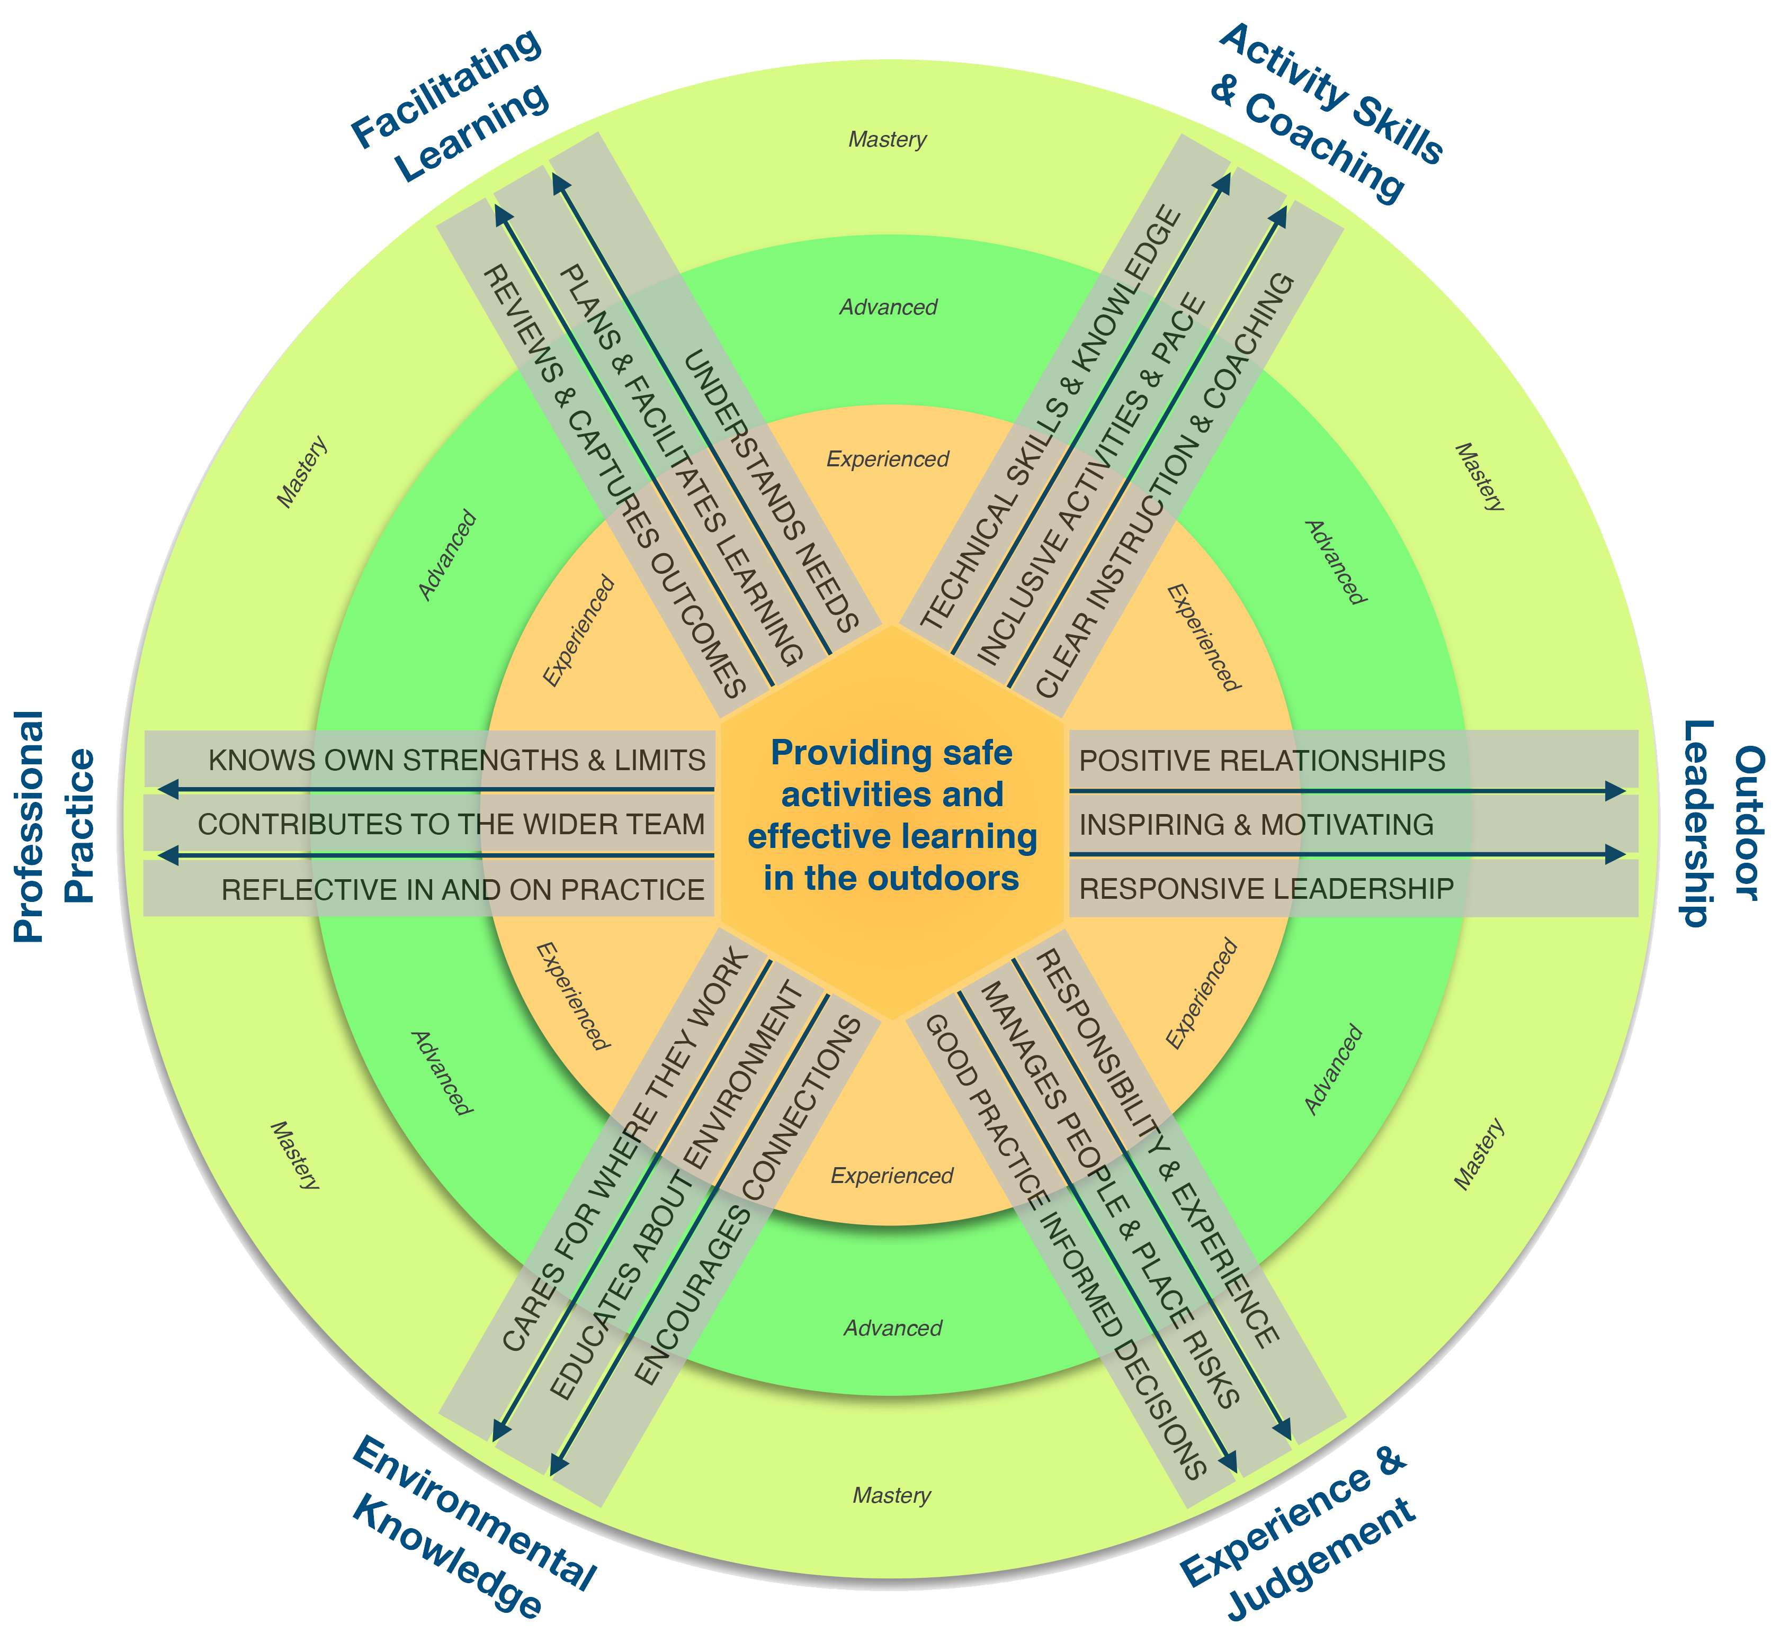

|  |  |
| --- | --- |
| What you like or appreciate about where you are right now |  |
| Strengths – what you offer/are good at, at this point in time |  |
| Development areas - where you need/want to improve |  |

section3

Examples from your practice

This section includes your reflections on approaches to outdoor learning, the importance of the outdoors, and examples of reflective practice and outdoor leadership.

* Contrasting approaches to outdoor learning

|  |  |  |  |  |
| --- | --- | --- | --- | --- |
| 1 | After working with or visiting another outdoor learning provider (outside your organisation and with a different emphasis / style of working), explore what  they have in common with where you work, and what they do differently. | | | |
| **Alternative provider** | |  | **Date visited / worked there** |  |
| **Key differences** | |  | | |
| **Key similarities** | |  | | |

|  |  |
| --- | --- |
| 2 | Give a brief description of the underlying philosophy, beliefs or approach to outdoor learning that you follow where you work. |
|  | |

|  |  |
| --- | --- |
| 3 | The outdoor sector is wide and varied, please outline some of the options available for working or volunteering in outdoor learning.  Describe which area(s) interest you most. |
|  | |

* Professional Ethics

|  |  |
| --- | --- |
| 4 | Read through and discuss the IOL Code of Professional Conduct with your coach.   * What was in there that you didn’t expect? * Which sections are harder for you to consistently uphold? |
|  | |

* Equality and Inclusion

|  |  |  |
| --- | --- | --- |
| 5 | Discuss with your coach examples of how you promote equality and inclusion through your practice.  Give a brief summary for each below.  Give the approximate date, a description of the group and explain what you did. | |
| **A time when I have actively promoted equality** | | **A time when I have actively promoted inclusion** |
| Date:  Group:  Action: | | Date:  Group:  Action: |

|  |  |
| --- | --- |
| 6 | What action or research could help you further develop your approach to valuing diversity and promoting equality and inclusion with the individuals you work with? |
|  | |

* Reflections on Session Delivery

|  |  |  |
| --- | --- | --- |
| 7 | Choose a recent outdoor learning session that was significant for you - perhaps it did not go so well, or perhaps it was successful despite difficult circumstances. Talk it through with your coach.  Use Gibbs’ Reflective Cycle to make sense of the experience. | |
| **Description** | What happened?  When and where did it happen?  What did you and the other people do?  What was the outcome of the experience?  Why were you there and what did you want to happen? |  |
| **Feelings** | What were you feeling during the experience?  What were you feeling before and after the experience?  What do you think other people were feeling?  What do you think other people feel about the experience now?  What were you thinking during the experience?  What do you think about the experience now? |  |
| **Evaluation** | What was good and bad about the experience?  What went well?  What didn’t go so well?  What did you and other people contribute to the experience (positively or negatively)? |  |
| **Analysis** | Why did things go well?  Why didn’t it go well?  What knowledge (your own or others) can help you understand the experience?  What choices did you make and what effect did they have? |  |
| **Conclusion** | What did you learn from this situation?  How could this have been a more positive experience for everyone involved?  What skills do you need to develop to handle a situation like this better?  What else could you have done? |  |
| **Action Plan** | If you had to do the same thing again, what would you do differently?  How will you develop the required skills you need?  How can you make sure that you can act differently next time? |  |

*Questions from: Gibbs G (1988). Learning by Doing: A guide to teaching and learning methods. Further Education Unit. Oxford Polytechnic: Oxford and* [*www.ed.ac.uk/reflection/reflectors-toolkit/reflecting-on-experience/gibbs-reflective-cycle*](http://www.ed.ac.uk/reflection/reflectors-toolkit/reflecting-on-experience/gibbs-reflective-cycle)

|  |  |  |
| --- | --- | --- |
| 8 | Put into practice what you wrote about above.  Please write a short statement about how you used the learning from your previous session and what impact it had. | |
| **Title of Session** | | **Date** |
|  | | |

* Championing the environment

|  |  |  |  |  |
| --- | --- | --- | --- | --- |
| 9 | Describe two experiences where you feel you have gone “above and beyond” with your group and inspired them to respect and preserve the environment. | | | |
| Date: | | Group: | Action you took: | Impact with the group: |
| Date: | | Group: | Action you took: | Impact with the group: |

* Using feedback to improve

|  |  |  |  |  |
| --- | --- | --- | --- | --- |
| 10 | Discuss some examples of how you have used feedback to improve the sessions you deliver with your coach. Give a brief summary below. | | | |
| **Participant feedback** | | Date: | Feedback received: | Improvement made: |
| **Line manager or customer feedback** | | Date: | Feedback received: | Improvement made: |
| **Respected colleague feedback** | | Date: | Feedback received: | Improvement made: |

* Professional Development Plan

|  |  |  |
| --- | --- | --- |
| 10 | Look back at your reflections against the professional development map and think about your short-term goals and medium- or longer-term aspirations in outdoor learning. Give a summary of your thoughts below. | |
| **Short term goals – where next?** | |  |
| **Future aspirations in outdoor learning** | |  |
| **Obstacles you may have to overcome to reach your goals** | |  |
| **The strengths and skills you can draw on to keep you moving forward** | |  |
| **Who can support and encourage you?** | |  |
| **Your next steps after completing RPIOL** | |  |

section4

Employer Backing

This section confirms that the professional approach you have described in your application is what happens reliably in practice.

* Session observation 1

**To be completed by a line-manager with experience of assessing competence in leading outdoor learning. Following each observation please talk through what you noticed, how the session went and what the candidate has learned.**

Where a line-manager is not available (for example you work alone or run your own business) your RPIOL Coach or another [APIOL award](https://www.outdoor-learning.org/APIOL-LPIOL-Member-Map) holder / [Recognised Professional](https://www.outdoor-learning.org/APIOL-LPIOL-Member-Map) who is able to offer a reliable opinion of your competence can complete this observation.

|  |  |  |  |
| --- | --- | --- | --- |
| Observed Session 1 | | | |
| Group |  | Date |  |
| Session activity(s) |  | | |
| Intended Outcomes |  | | |
| Candidates reflection on how they facilitated the session | | | |
|  | | | |
| Observer comments on participant’s ability to LEAD a safe and engaging outdoor learning session (prepare, deliver, supervise, engage, review, complete). | | | |
|  | | | |
| Signed |  | Date |  |
| Position |  | | |

* Session observation 2

**To be completed by a line-manager with experience of assessing competence in leading outdoor learning. Following each observation please talk through what you noticed, how the session went and what the candidate has learned.**

Where a line-manager is not available (for example you work alone or run your own business) your RPIOL Coach or another APIOL award holder / Recognised Professional who is able to offer a reliable opinion of your competence can complete this observation.

|  |  |  |  |
| --- | --- | --- | --- |
| Observed Session 2 | | | |
| Group |  | Date |  |
| Session activity(s) |  | | |
| Intended Outcomes |  | | |
| Candidates reflection on how they facilitated the session | | | |
|  | | | |
| Observer comments on participant’s ability to LEAD a safe and engaging outdoor learning session (prepare, deliver, supervise, engage, review, complete). | | | |
|  | | | |
| Signed |  | Date |  |
| Position |  | | |

* Confirmation of Knowledge and Skills

The RPIOL Award requires candidates to have a total of at least one years' consolidated experience delivering outdoor learning plus formal or informal training/education relevant to the sessions they deliver.

|  |  |
| --- | --- |
| Employers are asked to confirm that the candidate has demonstrated knowledge and skills to reliably meet the criteria: | *ü* |
| 1.1 Prepare for outdoor learning sessions, identifying activities, intended outcomes and tailoring approaches to the differing needs of participants |  |
| 1.2 Deliver outdoor learning sessions in line with own skills, experience, qualifications and organisational risk assessments and practice |  |
| 1.3 Supervise safety and plan for foreseeable problems (including but not limited to hazards, accidents, weather, equipment, behaviour) |  |
| * 1. Engage individuals and groups with activities and progress towards intended outcomes |  |
| 1.5 Review experiences with participants, assisting them to reflect on what they have learnt and consider how they can use or develop their experience in the future |  |
| 1.6 Complete sessions in line with organisational practice, including managing the venue and equipment used |  |
| 2.2 Follow recognised good practice and organisational policies and procedures (including but not limited to health & safety, risk assessments, sustainability, safeguarding, equipment care) |  |
| 2.3 Demonstrate a positive approach and work collaboratively with team members to deliver Outdoor Learning |  |
| 2.4 Contribute to session development and offer recommendations for change |  |
| 3.2 Actively encourage whole group participation, value diversity and promote equality & inclusion |  |
| 3.3 Build positive relationships and communicate effectively and professionally with colleagues, customers and stakeholders |  |
| 5.2 Recognise the boundaries of your competence, experience and qualifications in the activities and environments you use |  |

|  |
| --- |
| Employer view of the candidate’s strengths and special qualities |
|  |

**I can confirm that to the best of my knowledge** the applicant named above meets the above criteria and I can therefore support their RPIOL application.

|  |  |  |  |
| --- | --- | --- | --- |
| Name: |  | | |
| Contact email: |  | | |
| Signature: |  | Date |  |

*Where an employer is not available (for example you work alone or run your own business) your RPIOL Coach or another APIOL award holder / Recognised Professional who is able to offer a reliable opinion of your competence can complete this confirmation.*

section5

Professional Endorsement (RPIOL Coach)

This section is completed by your RPIOL Coach and confirms you have reflected on your experiences and can describe your professional approach to delivering outdoor learning.

|  |  |
| --- | --- |
| RPIOL Coaches are asked to confirm that the candidate has demonstrated the knowledge and skills to reliably meet the criteria: | *ü* |
| 1.4 Engage individuals and groups with activities and progress towards intended outcomes |  |
| 1.5 Review experiences with participants, assisting them to reflect on what they have learnt and consider how they can use or develop their experience in the future |  |
| 3.1 Articulate the effect the outdoors has had on you and what motivates your group leadership style and approach |  |
| 3.3 Build positive relationships and communicate effectively and professionally with colleagues, customers and stakeholders |  |
| 3.4 Consistently uphold IOL’s Code of Professional Conduct in your work and demonstrate compliance with outdoor first aid, safeguarding, data protection, disclosure (DBS), and similar requirements |  |
| 4.1 Encourage participants to appreciate the wonder of the outdoors and encourage lifelong engagement for health, wellbeing and other benefits |  |
| 5.4 Consider your future aspirations in outdoor learning and how you can take action towards your goals |  |

|  |  |  |
| --- | --- | --- |
| Coach’s view of the candidate’s strengths and special qualities | Arrow: StraightComplete this section to help the assessor prepare for the professional discussion. | |
|  |
| Suggested areas of focus for future development | |
|  | |

**I can confirm that to the best of my knowledge** the applicant named above meets the above criteria and I can therefore support their RPIOL application.

|  |  |  |  |
| --- | --- | --- | --- |
| Coach name: |  | | |
| Contact email: |  | | |
| Signature: |  | Date |  |

RPIOL Application

## In applying to be a Registered Practitioner of the Institute for Outdoor Learning you agree:

1. Your application will be assessed by the IOL Professional Standards Team and your RPIOL Assessor in accordance with the current published criteria and process.
2. To only use the RPIOL wording, logo, etc. in a way that conforms to IOL guidelines
3. IOL retains the right to withdraw accreditation at any time, including the reasons:
   1. Failure to comply with or uphold the accreditation criteria
   2. Failure to comply with the policies and procedures of IOL
   3. Misuse of any branding, wording or logos of the Institute for Outdoor Learning

Your RIPOL Application also includes the requirements for recognition as an Associate Professional in Outdoor Learning

|  |  |
| --- | --- |
| **I commit to safe, ethical practice and agree to abide by the IOL** [**Code of Professional Conduct**](https://www.outdoor-learning.org/Good-Practice/Good-Practice/Members-Code-of-Conduct) |  |

|  |  |
| --- | --- |
| **I agree to provide evidence of completing CPD annually and being up-to-date and connected to current good practice** |  |

|  |  |  |
| --- | --- | --- |
| **I confirm that I have a total of at least one years' experience* delivering outdoor learning plus relevant learning enabling me to:** | |  |
| 1. **Lead safe and engaging outdoor learning sessions** 2. **Organise resources and deliver within agreed programmes** 3. **Prepare for and achieve intended outcomes** |  | |

*\* Experience can be full time, part role or volunteer in any area of outdoor learning as an instructor, facilitator, teacher, coach, etc. in any outdoor activity.*

|  |  |
| --- | --- |
| Signature: |  |
| Date: |  |

|  |  |
| --- | --- |
| I consent for my name to be listed on a public register of Associate Professionals in Outdoor Learning |  |

Data is collected for the purposes of administering this application only. [IOL](https://www.outdoor-learning.org/Help/Privacy) may contact you to verify authenticity but you will not be contacted for marketing or any other purposes.

* Requesting your professional discussion

Professional discussions are **arranged by the IOL Office** **following submission of your fully completed application form**. They usually require 2-3 weeks’ notice to set-up and are typically conducted by online video lasting approximately 40 minutes.

Email your completed and signed form as a .PDF or .JPEG to [institute@outdoor-learning.org](mailto:institute@outdoor-learning.org)