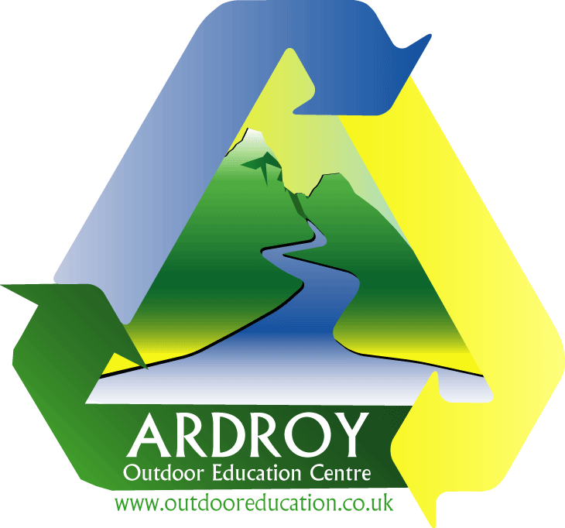

Job description

**Instructor (full time, permanent)**

**£22,700 – 26,700 p/a**

Ardroy OEC is based in the Loch Lomond & Trossachs National Park, on the shores of Loch Goil. Now in its 55th year, Ardroy has a proven track record of offering high quality outdoor education experiences. Our main customer base is primary schools, but we also work in partnership with several Scottish charities such as [Children 1st](https://www.childrenfirst.org.uk/get-support/our-services/bide-oot/) - delivering residential and outreach projects to support families across Scotland. Our most recent Impact Report is [here](https://tinyurl.com/23-24ArdroyImpact).

If you are a keen and enthusiastic person with a belief in the benefits of learning through the medium of the outdoors, we want you to join our team!

**Duties**

* Deliver all the activities at Ardroy in an educational, fun, and safe way. These include gorge walking, abseiling, adventure days, Jacob’s Ladder, expeditions, woodland skills, canoeing and kayaking.
* While working with the same group throughout their visit to Ardroy, rapidly develop a good rapport and facilitate meaningful experiences for each person. For schools, many of the learning outcomes will be derived from the Curriculum for Excellence.
* Ensure the physical and emotional well-being of all participants in potentially hazardous environments.
* Facilitate reviews at the end of each day and the end of the course to help participants process what they have learnt and set themselves future goals.
* Provide overnight cover by sleeping in the centre on a rota basis and being ‘on call’. Teachers/leaders have primary responsibility for groups during the night, but one member of Ardroy staff sleeps in the centre overnight to respond to unforeseen events. You will be renumerated for ‘on call’ nights you sleep in the centre.
* Assist with the upkeep of the centre and facilities.
* Give and be prepared to receive feedback to ensure that Ardroy - and you - continue to develop.
* Assist with the running of our Children 1st Partnership outreach and residential programs. To view our partnership video please go to [here](https://youtu.be/vDmyK48CJ8Y?si=7TW2AQpyBTsHtUeM).

**Person Specification**

**Essential**

At least two years experience of professional practice in outdoor education & at least two of the following:

* RCI training (formally SPA) or CWA.
* ML training or Lowland Leader award or HML award
* British Canoeing Paddlesport Leader award or other equivalent combinations (eg UKCC Level 1 +3*; Paddlesport Instructor + 3*; Sheltered Water coach + 3*; Sea Coach; Canoe Coach; 4* Leader (Sea or Canoe); Sea Leader; Canoe Leader).

In addition to:

* Valid first aid certificate
* Experience of reviewing outdoor learning experiences.
* Experience of environmental outdoor education.
* Evidence of personal development and adventures in time off.

**Desirable**

* Assessment in ML/SPA/RCI or the higher BCU/SCA awards.
* D1 driving licence.
* RPIOL accreditation or evidence of working towards same.
* A higher level of competency in some aspect of outdoor education e.g. youth at risk, woodland/bushcraft skills, hard skills teaching etc.

**Application Details**

To apply, download an application form [here](https://www.ardroy-oec.co.uk/assets/recruitment/aoec%20application%20form%20-%20dr.doc)

Please note interviewees will be asked to run a 10 minute team building/ice breaker activity.

The successful candidate for this post will be required to complete a PVG disclosure.

If you wish to have an informal conversation, please [email us](http://www.ardroy-oec.co.uk/contact-form.asp) with a suggested time for a phone call and a contact number. One of the management team will then be in touch. It might be prudent to call us once you have sent the email, in case it goes into spam.

**Dates**

Closing date **Sun 9th February 2025**

Interviews will be held (in person) on **Fri 21st Feb 2025**

(We will consider initial online interviews if distance/travel is an issue)

We would hope to have the successful candidate in post by late March, but we are open to negotiation for the right person.