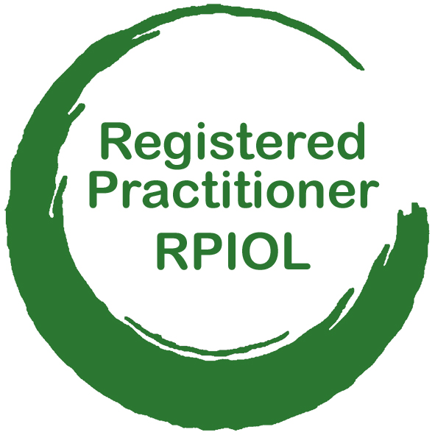
RPIOL Registration

Registered practitioners of the Institute for Outdoor Learning plan, prepare and lead safe and engaging outdoor learning sessions to achieve intended outcomes

Your name
Preferred contact email |  | Preferred contact phone
I wish to undertake the RPIOL Award and agree to pay the RPIOL Fee of £85 |  | Signature

Self-assessment
yes / no
- Do you have at least 1-2 years of experience with individuals or groups in the role of instructor, teacher, coach, leader, youth worker, volunteer, ranger, education officer, etc.?
- Do you have training, education or CPD courses to give you the knowledge and skills to safely plan, prepare and lead safe and engaging outdoor learning sessions?
- Do you have the time, space and desire to reflect on your experience to date and discuss your strengths, interests and future aspirations with a coach?
- Have you read through the RPIOL criteria and are ready to gather the evidence you need to show you meet them?

Membership of IOL
- If you are not yet an IOL Member you should join online at the IOL website first. https://www.outdoor-learning.org/Members/Membership/Join-IOL
- Student / trainee / apprentice membership costs £2.50 per month by direct debit.
Your IOL membership number |  | IOL region

Connect with an Approved RPIOL Centre
- An Approved RPIOL Centre will support you with session observations and confirmation of your knowledge and skills.
- They can be either an Organisational Member of IOL
(offering RPIOL to employees and volunteers), or an
IOL Home Nation or Region (offering RPIOL to independent practitioners).
- https://www.outdoor-learning.org/RPIOL-Centre-Map
Your Approved RPIOL Centre |  | Name of RPIOL facilitator

Connect with a RPIOL Coach
- Your Approved RPIOL Centre will help you identify an IOL Coach who is an APIOL Holder or Recognised Professional in Outdoor Learning
- Your RPIOL Coach supports you through RPIOL and completes your professional endorsement
Your RPIOL Coach |  | Their IOL membership number

Send to IOL
- Email this form as a .PDF or .JPEG to institute@outdoor-learning.org
- IOL will contact you to confirm your registration is accepted and send you your RPIOL Application to complete

